Assignment 2

Create three instance and install nginx and apply ALB

. First we have to create security group with inbound rule of HTTP port 80

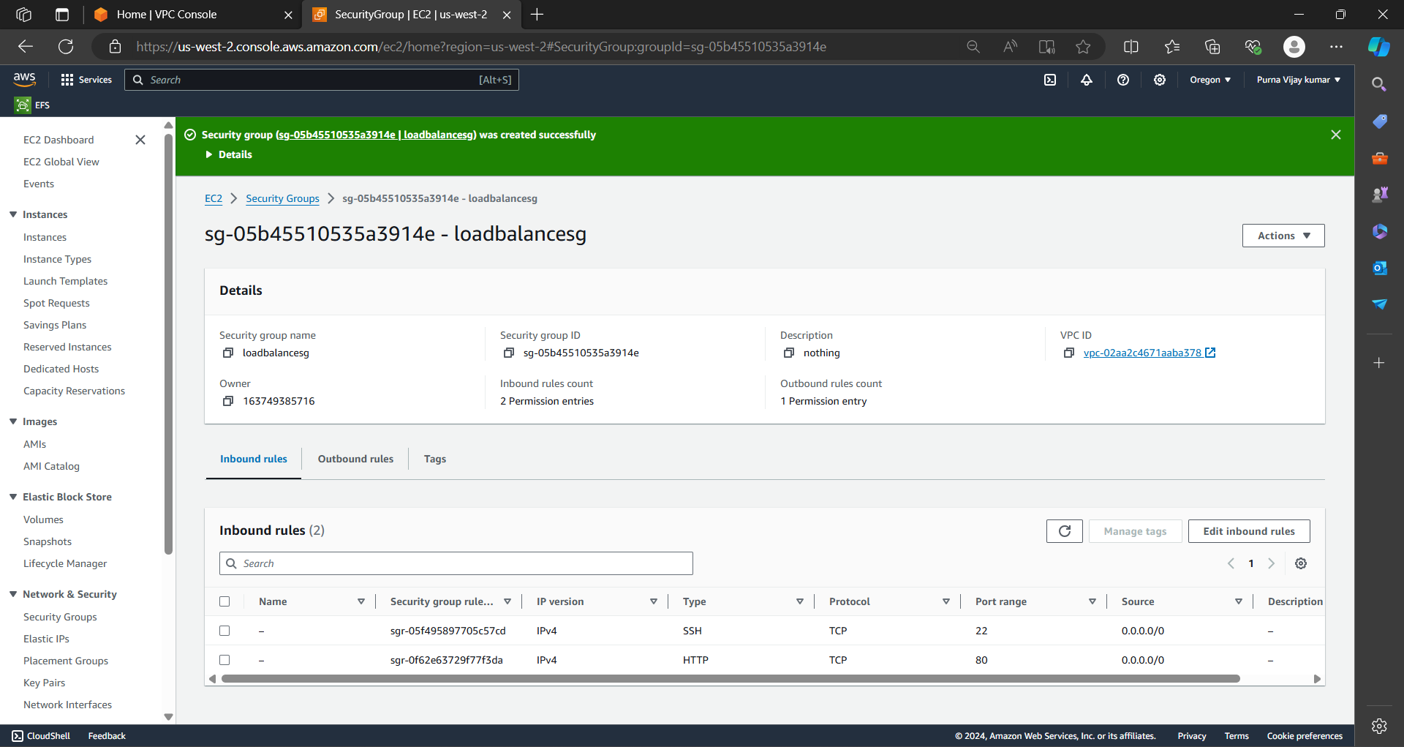

. Launch three instance with security group in different availability region.

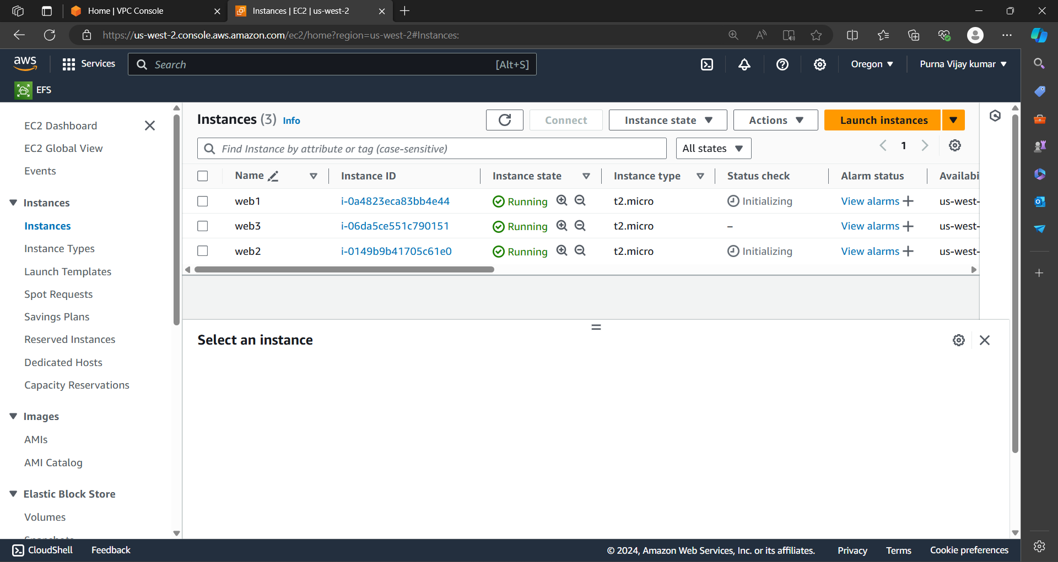

. Run the instance one and update it and install nginx with commend “yum install nginx -y” after that “cd /usr/share/nginx/html”

. And remove index.html after that create file with ‘vi’ command

. Then restart the nginx with “systemctl restart nginx” command.

. ALL steps applied to the three instances.

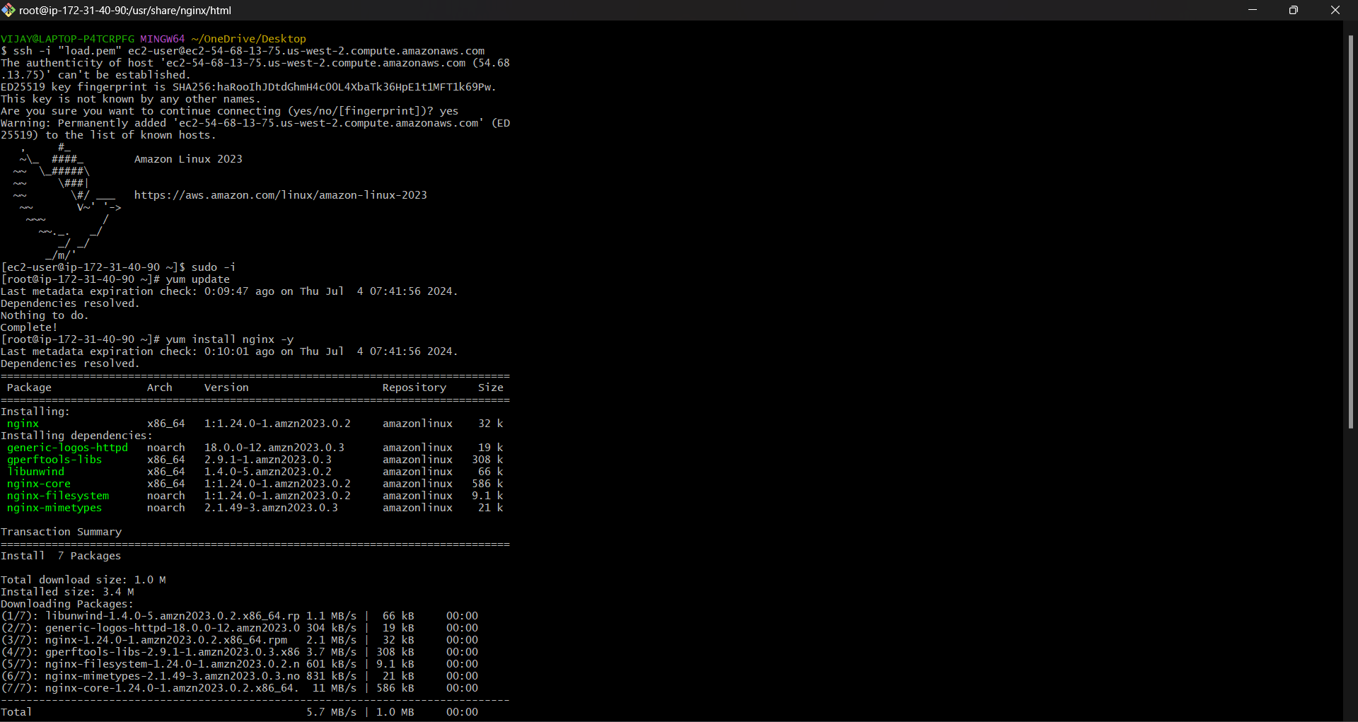

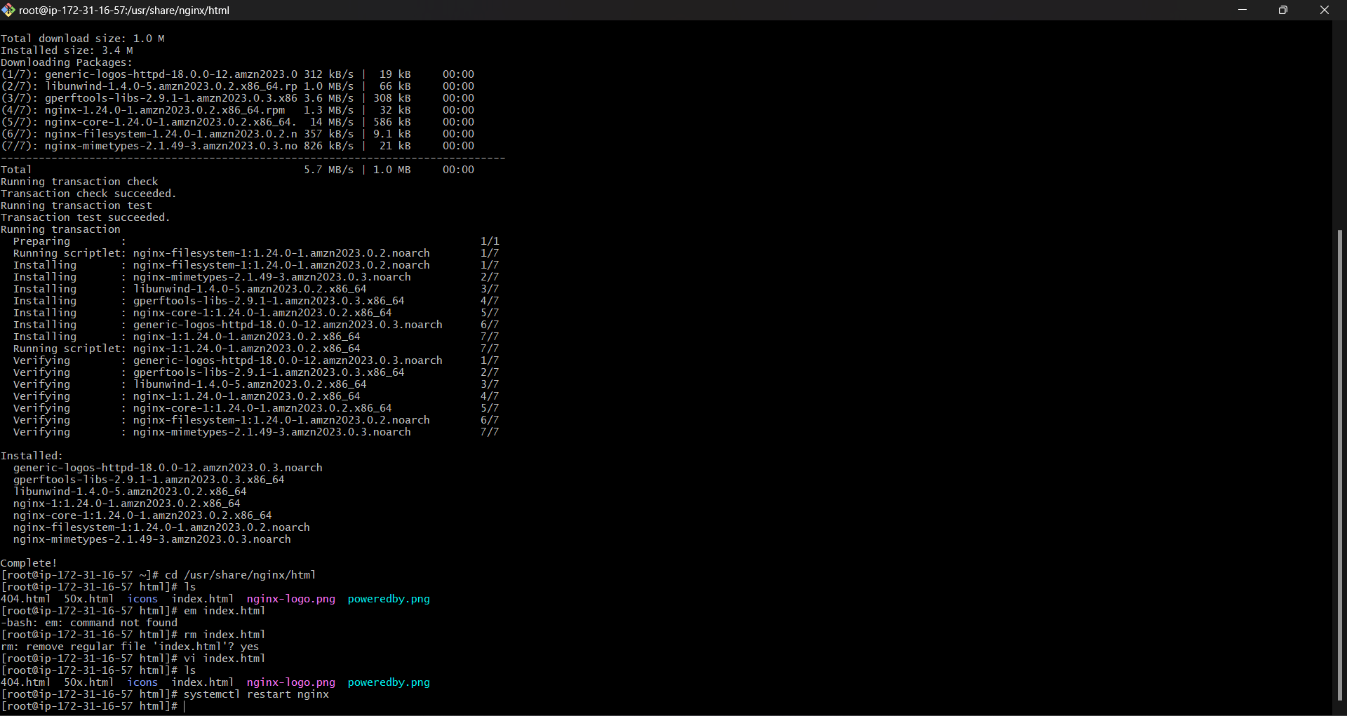

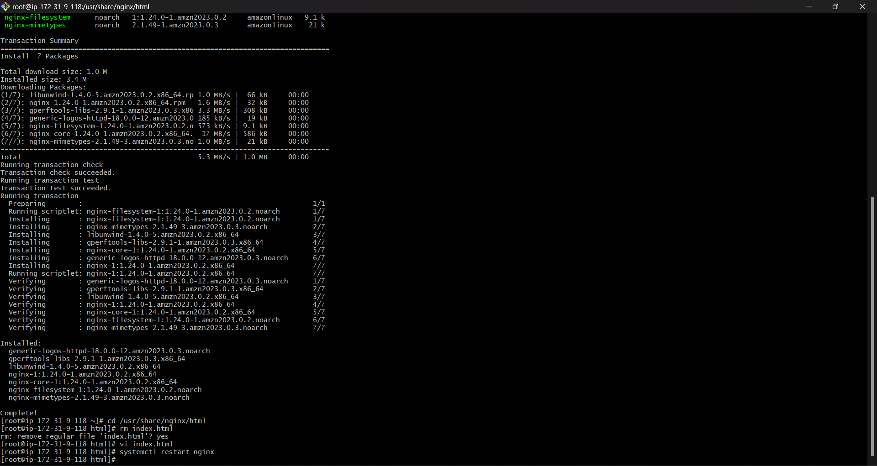

. Create a target group

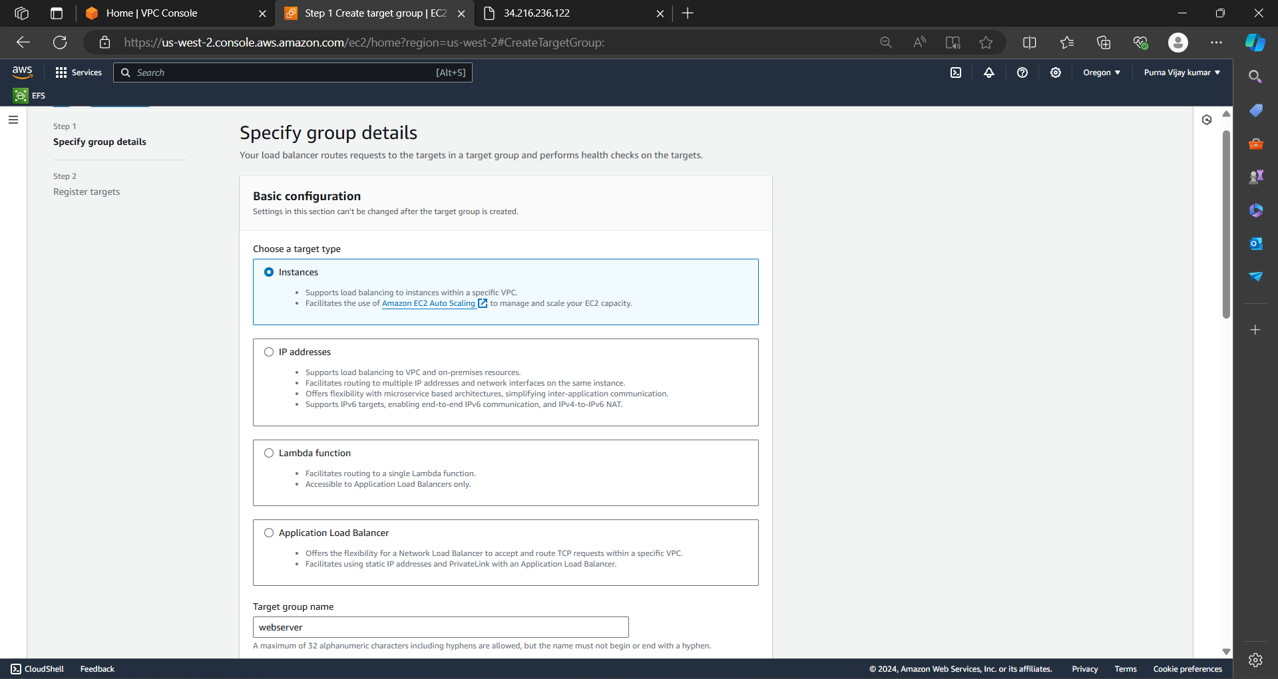

.select the instance that you are created.

. And click on the “include as pending below”

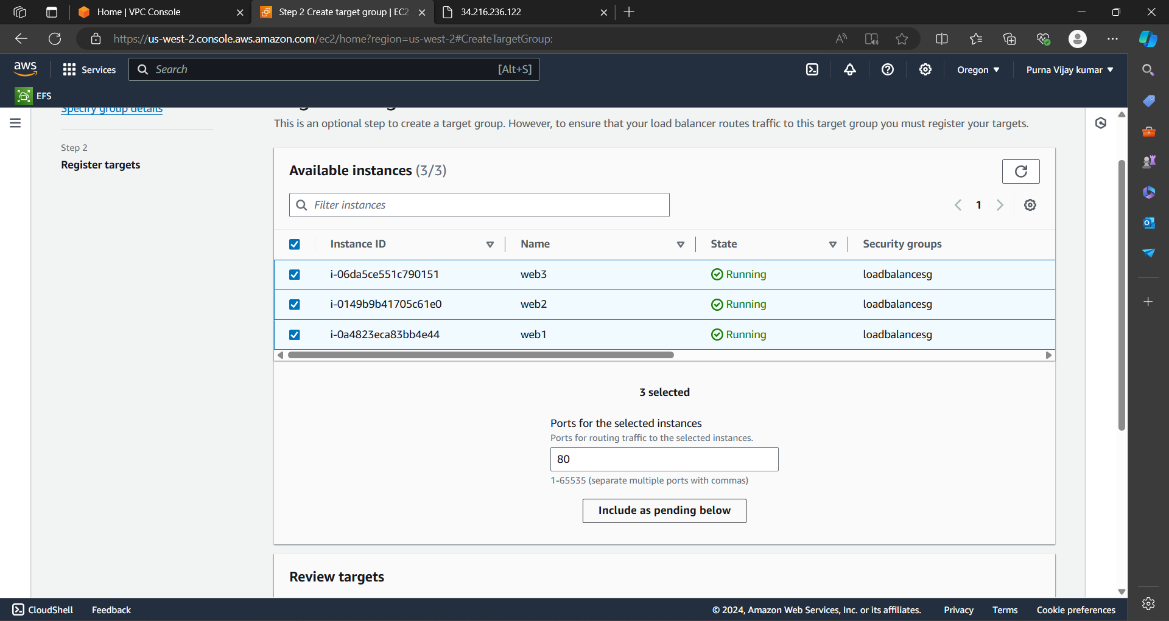

. And click on the create target group

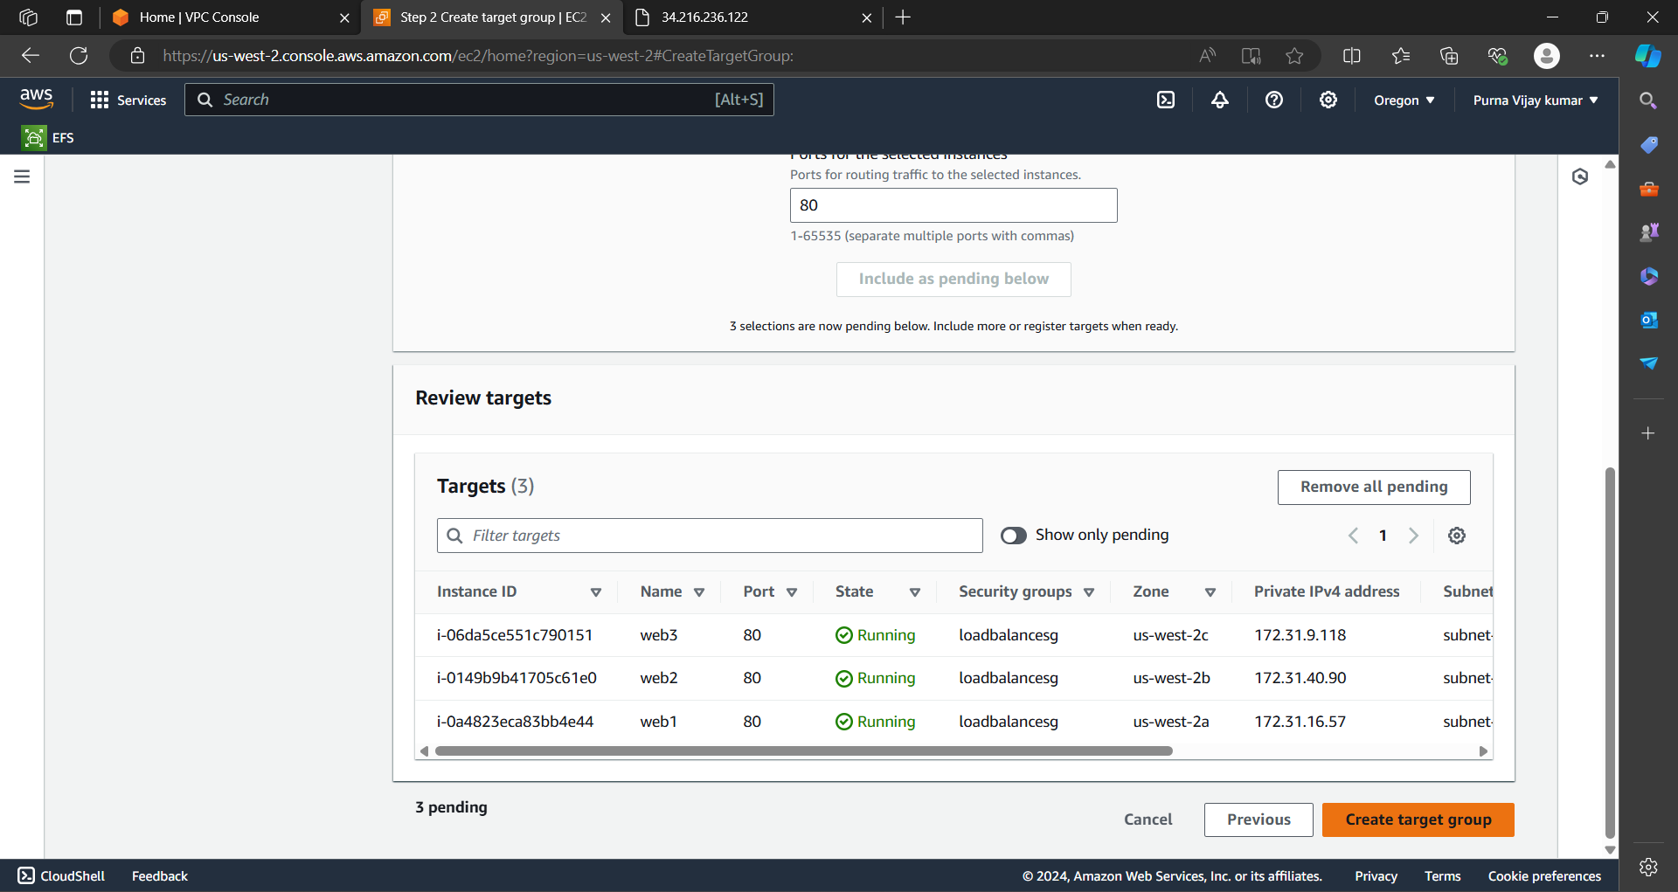

. create a application load balancer and select subnets and also select the security group.

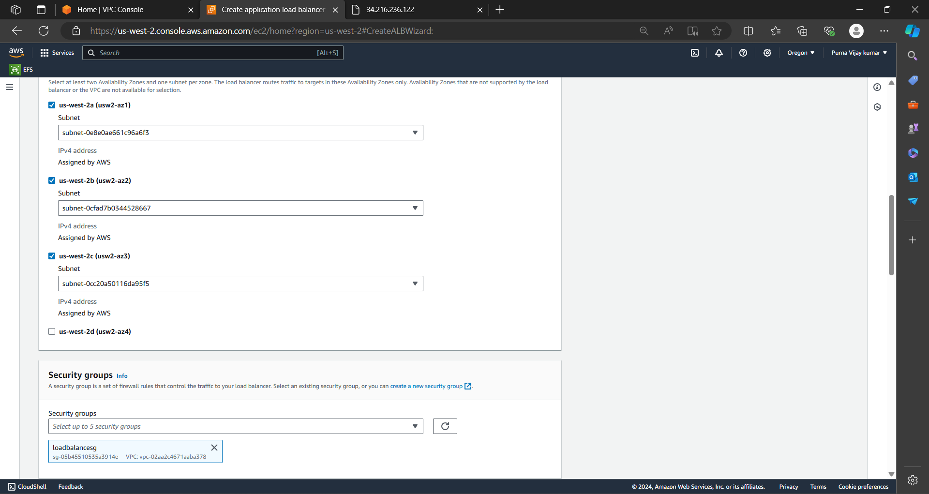

. After creating that copy the DNS name.

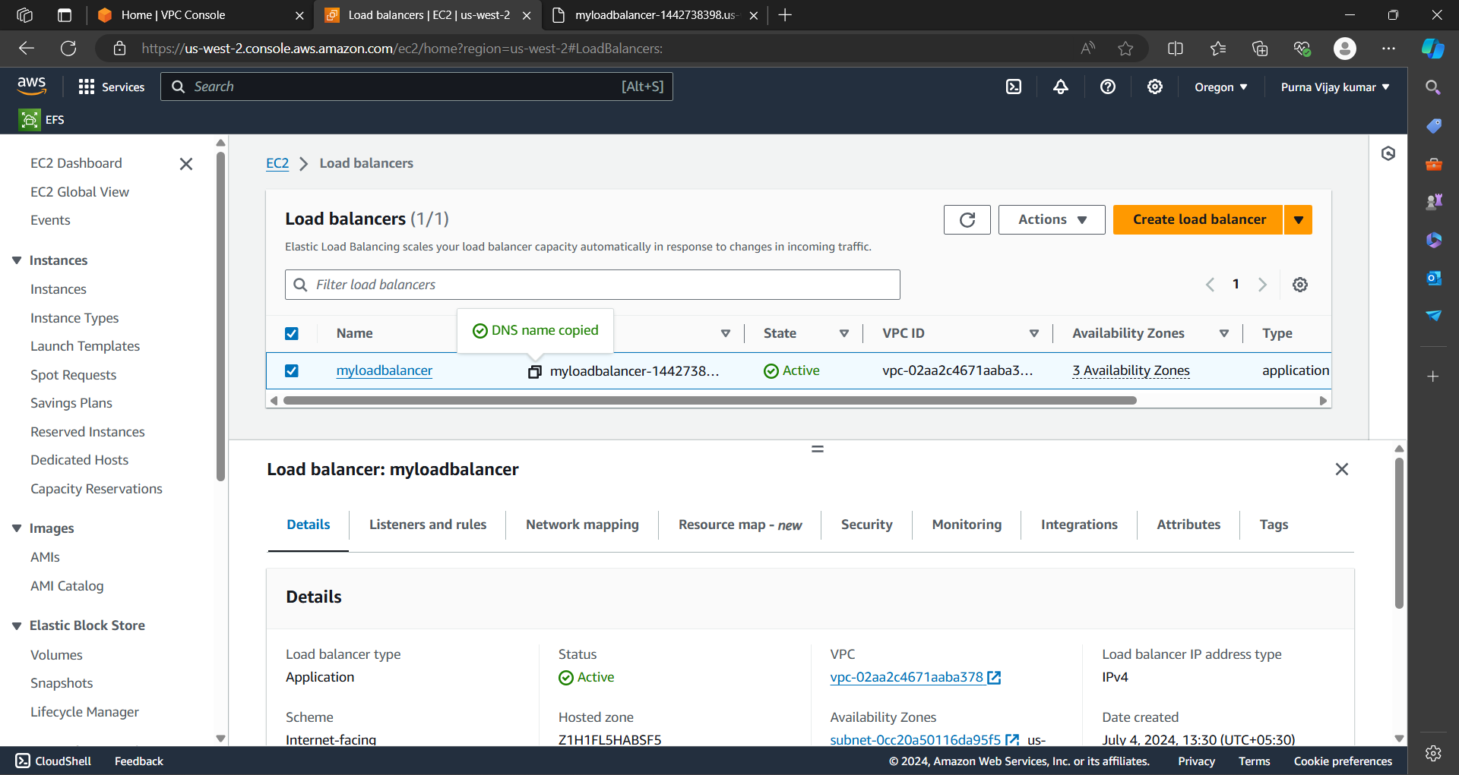

. Browsed the DNS name and you can see that server .



. After refreshing the browser it can balance the load from one server to another we can see below fig.

